4.1 Use Case Diagram
Lost and found board offers a seamless, user-centered fitness experience with personalized plans, easy account management, and smooth interactions that keep users focused on their goals. In Figure4.1 shows UseCase diagram of Lost and found board

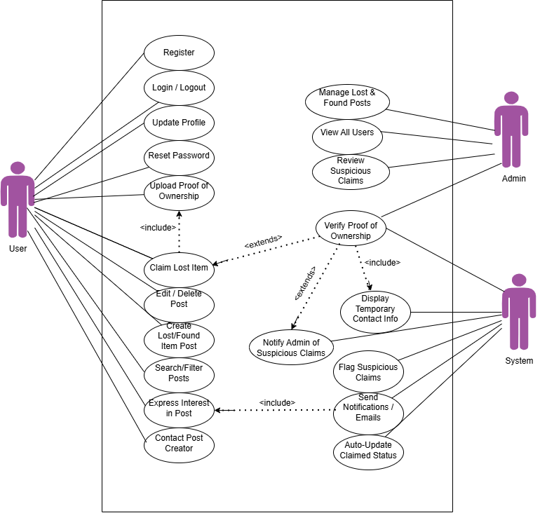

Figure 4.1: UseCase diagram of Lost and found board

